Abdul Moiz Farooq, Amnah Khan, Husnain Arif , Maria Hameed

Momina Ramzaan, Nayab Javed, Talha Munir

Mam. Zaheema Iqbal

HU212

4 January 2016

Prevalenceand Effectiveness of Entertainment Augmented Education in Children

# Outline:

Media and technology havechanged the lives of people of all age groups across the globe. In the last five years the use of electronic devices like smart phones and tablets has become common.Mobile devices are widely used by children and innovative examples of mobile learning are popping up worldwide. This research focuses on how the media is influencing the very young children (toddlers) and their families and how people can use applications and mobile devices to help their kids learn. Apps can provide children with an intuitive and enriched learning experience and this makes apps attractive to parents and teachers as a way to help children access new information. Nowadays applications are the great source of learning as well as entertainment.

This study explores the prevalence and effectiveness of using apps to promote learning among preschool and elementary aged children as the apps for “toddlers/Pre-Schoolers” are the most popular apps and are experiencing the great growth since last 5 years.

# Organization of this document:

This document assesses effectiveness of Edutainment (Education and Entertainment) applications in teaching Pre-School kids. The first section provides an introduction to the topic and prevailing trends in society. The section on statistics is compilation of mobile device usage statistics for young children. Next, a background of research has been presented which is followed by a detailed discussion on the topic from perspective of effectiveness of edutainment app and child psychology. Based on the findings during the study an account of suggestions about application development is also present. A summary and conclusion drawn from the discussion are present at the end along the citations.

Thesis Statement:

The ubiquity of mobile devices and computing technology has led to prevalence of idea of education through entertainment and this is being viewed as very effective in child education by experts world-wide.

# Introduction:

The science of learning has shown that the humans learn most when they are actively involved with the learning process. The word “actively involved” means the person should be physically and mentally involved participating or practicing the content being learnt. In order to learn children need to stay on the task they are performing and should remain free from distractions. Digital devices such as IPads, smart phones and handheld video game consoles have such apps that can help children in learning and developing their skills which they need to compete but with these potential comes there are certain challenges which should also be addressed. The science of learning also tells us that when the information is meaningfully related to the past knowledge it is processed at a deeper level. Digital devices and applications that allow and encourage children to connect new information and learn new skills in their daily life will be a more effective learning source for the kids for example, drawing a triangle using tools in apps will be more effective than an app in which children simply shows a triangle.

Method of collection of data:

* Primary data:

The basic primary data has been collected from

* Observation:

Do young children find desktop games and apps interesting?

How much do they learn from it?

Are these applications actually helpful for learning purposes without leaving a negative impact?

* Secondary data:

sources of secondary data for this research document are:

1) Published articles by research scholars:

-- Gaming as Cognitive Tool for learning by Hogle G Jan

2) Publics records and statistics by Pew Internet Project survey on "Use of Mobile applications for Edutainment"

3) Unpublished online data by various research organizations and scholars

Background:

The word edutainment comes from the computer industry. It was first coined several years ago to describe CD-ROM programs, mainly for children that were designed for education or teaching and that had an entertainment component to increase their appeal. The term was adopted by the family entertainment industry only about a few years ago. Although the term is still new, the concept of edutainment is not.

But what is new is the idea of designing facilities specifically for edutainment. One of the reasons for this is the changing role of leisure in our society. Research in early childhood development has clearly established that preschool children learn best through self-directed play rather than in structured learning or academic-type settings. Most day care and kindergarten providers recognize that open-ended play is nature's process for children to learn and develop cognitively, emotionally, physically and socially. There also is considerable debate in the field of early childhood education about what is called "developmentally appropriate practices" in the primary grades. Many are calling for a return to a child-sensitive and whole child approach to teaching and learning that incorporates play, rather than the traditional model of teacher-assigned and structural academic learning.

As a compound word of education and entertainment, edutainment refers to learning content that enables learners to have fun while learning, as in playing games. Unlike general games, edutainment aims to reinforce the motivation for education and raise the learning effect. Instead of being limited to the game function like serious games are, edutainment incorporates educational textbooks, materials, toys for children, robots or machines for learning, and even offline board games.

As there has been a recent increase in the number of children who use edutainment content based on smart devices, the current study conducted an exploratory research to identify the design factors of smart phones that influence the usage of mobile edutainment content for preschool children. The most frequently used content through smart devices is edutainment content, which has an ever increasing market size. Following an increase in the number of preschool children's usage of smart devices like smart phones and tablet PCs, the development of smart contents for children has been triggered. Among the smart contents for children, the most popular is edutainment content. Because edutainment content can elicit children's inner motives and immersion, its importance as a learning tool is growing bigger. In addition, edutainment content intends to naturally improve the learning effect by using a form of 'play' instead of directly exposing its study purpose.

Useful Statistics:

In this middle childhood developmental period especially, the growing ubiquity of children’s engagement with media is important. According to the Kaiser Family Foundation and Sesame Workshop studies, 8-year-olds spend as many hours engaging with various screens as they do in school, and preschoolers are spending about four hours per day on media (The Nielsen Company, 2009), far more than they devote to reading and outdoor play.

It is as yet uncertain what exactly young children like about mobile devices and apps, or to what extent they can use and learn from them.



Figure 1. Parent's engagement with kids while using different gadgets.

## Parent’s engagement with kids in using apps and mobile devices:

In a Cooney Center nationwide 2013 survey, parent engagement accounted for a third of the time 2- to 4-year-olds spent with mobile devices. Common reasons for parent engagement were to protect the child from inappropriate content and to spend time with the child. In a recent qualitative study, parents of young children expressed ambivalence about the effects of mobile media exposure on their child and their own ability to set limits. Parents are seeking anticipatory guidance on the use of media for their children, and additional research is needed to develop recommendations in this area. Our study also found that 1 in 3 children used several media devices at the same time. Like traditional media use, child use of mobile and interactive media does not occur in a vacuum. Many factors, including parenting style, socioeconomic status, and child temperament, modify the positive and negative effects of media on children’s behavior and development.

Mobile and interactive media have great potential to promote learning through joint engagement between caregivers and children, by demonstrating ideas for parent-child activities, or by modeling teaching strategies.

Prevalence:

The rapid adoption of mobile devices by children is likely to have an impact on family dynamics and child health, development, and literacy. Apps for the young children/toddlers are the most popular (58%) andit is 20 % more than the percentage of apps used by adults which is 40%. This shows that the apps for young children have high demand and supply.

## Fourteen percent of apps are planned to be used in schools for the purpose of learning. A quick glance of the apps reveal that these apps include those that are primarily used in study aids, test preps, etc.

## Market Growth of Children Apps:

Since 2009 there has been a great increase in percentage of apps for kids. This percentage is now increased to 72%. This category has been experiencing a greatest growth of 23% whereas the category for middle school has also been seeing a jump of 14%. “Children educational apps” is a growing market which should be considered important by developers, policy makers and researchers. The graph given below is showing the age targeted between 2009 and 2011.

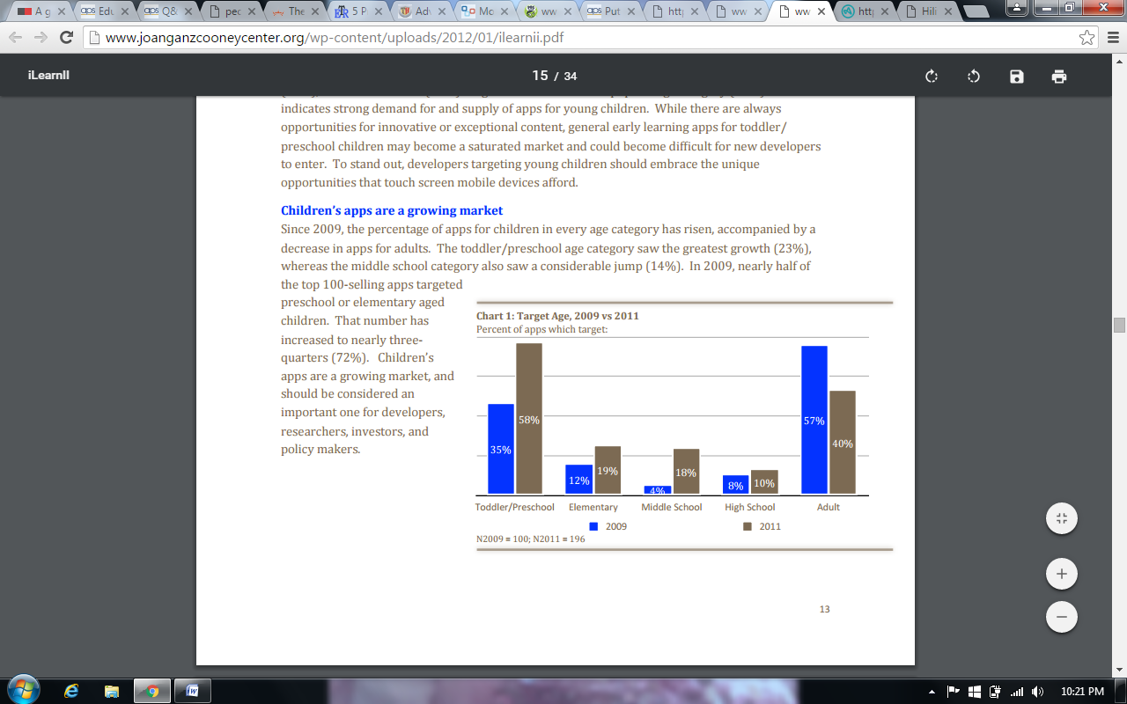

## Universal Access:

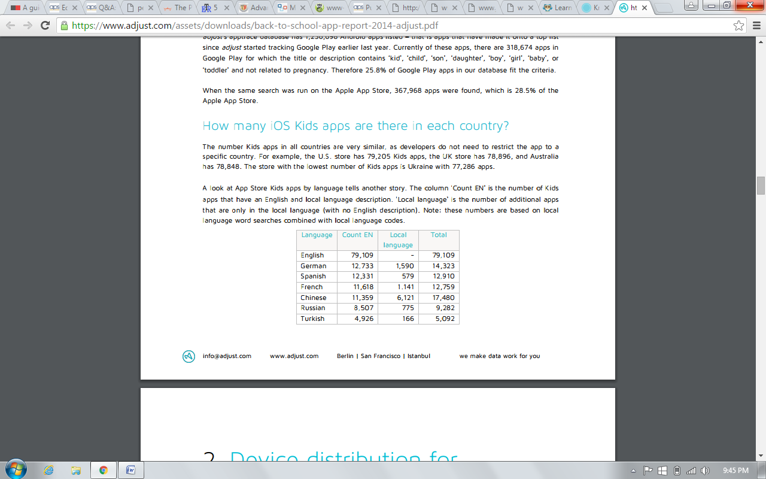As the developers don’t restrict the apps to a specific country due to which all countries almost have the same number of kids. The number of Kids apps in all countries are based on local language word searches combined with local language codes.

## A Comparison of Opportunities and Challenges for Children Education through Technology:

|  |  |
| --- | --- |
| **Key opportunities** | **Key challenges** |
| * Encourage “anywhere, anytime” learning: Mobile devices allow students to gather, access, and process information outside the classroom. They can encourage learning in a real-world context and help bridge school, afterschool, and home environments. * Reach underserved children:   Because of their relatively low cost and accessibility in low-income communities, mobile devices can help advance digital equity, reaching and inspiring populations “at the edges” children from economically disadvantaged communities and those in developing countries.   * Improve 21st-century social interactions:Mobile technologies have the power to promote and foster collaboration and communication, which are deemed essential for 21st-century success. * Fit with learning environments:   Mobile devices can help overcome many of the challenges associated with larger technologies, as they fit more naturally within various learning environments.   * Enable a personalized learning experience:   Not all children are alike; instruction should be adaptable to individual and diverse learners. There are significant opportunities for genuinely supporting differentiated, autonomous, and individualized learning through mobile devices. | * Negative aspects of mobile learning:   Cognitive, social, and physical challenges must be surmounted when mobile devices are incorporated into children’s learning. Disadvantages include the potential for distraction or unethical behavior, physical health concerns, and data privacy issues.   * Cultural norms and attitudes:   Though many experts believe that mobile devices have significant potential to transform children’s learning, parents and teachers apparently are not yet convinced. A 2008 national survey found that most teachers see cell phones as distractions.   * No mobile theory of learning:   Currently, no widely accepted learning theory for mobile technologies has been established, hampering the effective assessment, pedagogy, and design of new applications for learning. Differentiated access and technology:   * Wide diversity among mobile devices represents a challenge for teachers and learners who wish to accelerate academic outcomes as well as for the technology producers who seek to facilitate such learning. * Limiting physical attributes:   Poorly designed mobile technologies adversely affect usability and can distract children from learning goals. Physical aspects of mobile technologies that may prevent an optimal learning experience include restricted text entry, small screen size, and limited battery life. |

Table 1. Comparison of Opportunities and Challenged for Children Education through Technology

# Effectiveness of Edutainment Apps for Children:

### Why desktop apps (games) as cognitive tools?

Cognitive tools can reduce the need for laborious activity and allow students to achieve goals they are already motivated to reach. Games are generally assumed to rouse student interest and motivation, this format is used in an attempt to create less tedious learning environments. Many teachers and researchers use games to supplement or replace traditional instruction, and the educational effectiveness of such approaches has always been positive especially among kids.

## Statistical Analysis:

**How current software applications are being used for child edutainment?**

In August of 2011, the Pew Internet Project found that 84% of parents with tablets download applications to their tablet and nearly half of parents with cell phones (48%) download applications. Many of these parents download applications for use by their children. After considerable research and surveys, the researchers at Pew Internet Project found that 34% of adults, whether parents or not downloaded applications for children.

The statistics show that 46% of these downloaders seek out for entertainment, 31% for learning or education and the rest 22% for both education and entertainment.

The statistics above shows the rapid growth of educational and entertainment apps for children. They are a good source of inculcating in young minds the sense of using technology in a productive way.

### Some Edutainment Applications for Toddlers and their Market Ratings:

* “Kids alphabet game” by FUN4KIDS- Rating 4.0
* “Monkey preschool lunchbox” – Rating 4.5
* “Alphabet for kids ” – Rating 4.1
* “Apps by Agnitus for iPad” – Rating 4.2

## Edutainment and child psychology:

Edutainment in children in early years can be summarized in following remarks:

* Children learn by observing their environment and consequences of their actions on their environment. They more often try to emulate whatever they observe.
* Children respond to a message depending upon its attractiveness and expected outcome.

### Possible Benefits of Edutainment for kids:

* Research suggests that gaming in its various forms can motivate and interest kids, increase retention of subject material, and improve reasoning skills and higher order thinking.
* Games are activities which engage the interest of the child and allow him to spend more time on activity than he would otherwise, leading to better learning of the instruction. It also raises more sustained interest in children in future encounters with the instructional content.
* Longer time on the task and increased interest developed due to apps and games could lead to more practice, more automaticity of pattern recognition, more efficient retrieval of concepts, and better use of basic knowledge.

### What are the possible challenges in developing games for child education?

Use of a game format for instruction does not always result in an effective learning environment, as there are several variables involved in creating a successful learning tool.

* When designing for specific audience, like kids of a certain age group there psychological approaches and understanding should be in focus. Creating complex and highly intuitive designs for kids can result in making the application confusing.
* The content should target the users in an effective way and should also fulfill the actual purpose of fun learning.
* The format should be intrinsically motivating and appropriately challenging. It should offer elements of curiosity, fantasy and control that keep child’s concentration.
* Designers should consider ways in which children might misunderstand lesson content, then design practice experiences which allow children to discover misconceptions and correct them.
* When designing games to provide practice, developers should consider results found when comparing behaviorism and cognitive framework designs.
  + E.g. game designers operating under principles of behaviorism usually create almost error-proof practice, anticipating that total success would be most effective and motivating for the kids.

# Tapping Tots (Edutainment Application for Toddlers):

Tapping Tots is the application developed by writers of base thesis report selected for this paper. The application has been developed after deliberate research on child psychology as well as the short coming in the apps already available in the market. A lot of hard work has been put in the development of the story line and the graphics to keep the end user engaged.

It specifically targets the children in their “preoperational stage” of cognitive development and has been designed in a way that children can relate to the objects while engaged in the storyline.Phonics of alphabets has been stressed upon as it helps kids to recognize alphabets in words when spoken.

# Summary:

Basically our research paper is about the effectiveness of edutainment application for pre-school kids. This focuses on how the media is influencing the very young children (toddlers) and their families and how people can use applications and mobile devices to help their kids in their learning. This study explores the feasibility and effectiveness of using apps to promote learning. The term edutainment is first used to describe the CD-program but now it is being used in term of family entertainment. The basic idea of this paper is to find the efforts that has been made in order to provide application on smart devices that helps pre-school kids to learn best through self-directed play rather than in structured learning or academic type settings. This enables kids to have fun while studying. This study uncovers that number of children who uses these apps have been increased drastically during few years. The market share of edutainment application increases these days and there are still a lot of space in this field. These app are the most popular among the young people. These are still certain challenges that needs to be addressed. It is still also uncertain what exactly young children like about mobile devices and apps, or to what extent they can use and learn from them. This study also suggests that parents have their concerns while their children uses smart phones. . Common reasons for parent engagement were to protect the child from inappropriate content. Many factors, including parenting style, socioeconomic status, and child temperament, modify the positive and negative effects of media on children’s behavior and development. Most important is parent-child or teacher-child interaction during media use such that, how we use technology rather than the technology’s qualities. There are applications in the market that allow parents know where their children are located and notify the parents when the child travels outside predestinated areas. Edutainment application provide many opportunities to enhance children’s learning but there are still some key challenges that needs to be addressed. These apps helps children to learn at any time and any place. All they have to do is to access the app. Mobile is now accessible to common people so these app helps unfortunate people to develop their skills. As we all know that each student has its own capacity of absorbing knowledge so these app helps them to fetch knowledge at their own capacity. At the same time, it’s disadvantages include the potential for distraction or unethical behavior, physical health concerns, and data privacy issues. There exists a school of thought who considers cell phones as mere distraction. Currently, no widely accepted learning theory for mobile technologies has been established. Poorly designed mobile technologies adversely affect usability and can distract children from learning goals.

# Conclusion:

Mobile phones have become integral part of routine activities. They have a great influence over all age groups, this influence is particularly prominent on kids. The studies reported here demonstrate that that children can learn better from educational apps as they are cognitively, emotionally, physically and socially involved in it. Kids will be kids and they will prefer driving cars or flying airplanes rather than downloading a mathematics App to learn mathematical tables. Edutainment content intends to naturally improve the learning effect by using a form of 'play' instead of directly exposing its study purpose. These apps act like a personal tutor, accessible anytime and anywhere. For instance “Smart Kitty” is an app for toddlers to improve their logical thinking and memory skills in an easy and fun way. A number of companies including Apple, Samsung and Amazon have now started to blend education with entertainment so that process of learning doesn’t become boring.

However edutainment apps is still a new trend and of course there will be many doubts among schools or college managements and students who want to adopt it.

Works Cited

Apple Press Releases. (2010). Apple reports quarterly results. Retrieved from http://www.apple.com/pr/library.

Apple Press Release. (January 5, 2010). Apple’s App Store downloads top three billion. Retrieved from <http://www.apple.com/pr/library>.

Shuler, (2009b). Source: Pockets of Potential

Chiong, C. (2010). Can video games promote intergenerational play and literacy learning? New York: The Joan Ganz Cooney Center at Sesame Workshop.

Fisch, S. M. (2004). Children’s learning from educational television: Sesame Street and beyond. Lawrence Erlbaum Associates, Mahwah, New Jersey.

Greystripe. (April, 2009). Greystripe Consumer Insights Report. Retrieved from <http://www.greystripe.com/aboutgreystripe/reports/>.

The Nielsen Company. (2009). Youth and media… Television and beyond. New York: The Nielsen Company.

Nielsenwire. (June 10, 2009). iPhone users watch more video… and are older than you think. Retrieved from <http://blog.nielsen.com/nielsenwire/online_mobile>.

NPD Group. (2010). Kids’ mobile entertainment & apps. Port Washington, NY: The NPD Group. Retrieved September 21, 2010, from http://www.npd.com/press/releases/ press_100920a.html

Purcell, K., Entner, R., and Henderson, N. (2010). The rise of apps culture. Washington, DC: Pew Research Center’s Internet and American Life Project. Downloaded September 16, 2010, from <http://pewinternet.org/Reports/2010/The-Rise-of-Apps-Culture.aspx>

Document: "Considering Games as Cognitive Tools" by Hogle Jan G

Shuler, C. (2007). D is for digital: An analysis of the children’s interactive media environment with a focus on mass marketed products that promote learning. New York, NY: The Joan Ganz Cooney Center at Sesame Workshop.

Shuler, C. (2009a). iLearn: A content analysis of the iTunes App Store’s Education Section. New York, NY: The Joan Ganz Cooney Center at Sesame Workshop.

Shuler, C. (2009b). Pockets of potential: Using mobile technologies to promote children’s learning. New York, NY: The Joan Ganz Cooney Center at Sesame Workshop.